Client | [Customer Name will be written here]
Project Name | [Project Name will be written here]

Table of Contents
1 Document Overview 4
1.1 Scope & Purpose 4
1.2 Version Numbers 4
1.3 Audience 4
1.4 Document Structure and Special Conventions 4
1.5 Definitions, Symbols and Abbreviations 5
1.5.1 Definitions & Terminology 5
1.5.2 Abbreviations 5
1.6 References 6
2 Assumptions 7
3 Deployment Platform 8
3.1 Server Side Modules 9
3.2 Online / GUI Modules 9
3.3 Database 9
3.4 Other 9
3.5 Software Platform 9
4 Hardware Platform 10
4.1 Server Side 10
4.2 Online / GUI Side 10
5 Installation 12
5.1 What other software must be installed first? 12
5.2 Installation of ZZZ-SubModule-1 12
5.2.1 How do I install? 12
5.2.2 How can I uninstall? 12
5.3 Installation of ZZZ-SubModule-2 12
5.3.1 How do I install? 12
5.3.2 How can I uninstall? 13
5.4 Known Problems and Workarounds 13
6 Getting Started and First Time Run 14
6.1 How can I quickly get started and test my installation? 14
Appendix 15
Document Control 15

Document Overview

Scope & Purpose

This document is the Installation Guide for the [Module Name]. The purpose of this document is to provide the steps and prerequisites for a successful installation of [Module Name].

Version Numbers

This Specification has been produced by the i2i Systems (i2i) following 3GPP specifications alike versioning scheme.

The contents of the present document are subject to continuing work and may be changed by i2i. Should the i2i modify the contents of the present document, it will be re-released with an identifying change of release date and an increase in version number as follows:

Version x.y.z
where:
x the first digit:
1 presented for information;
2 presented for approval;
3 or greater indicates approved document under change control.
y the second digit is incremented for all changes of substance, i.e. technical enhancements, corrections, updates, etc.
z the third digit is incremented when editorial only changes have been incorporated in the document.

Audience

The document may be read by the below audience;
- Operations

Document Structure and Special Conventions

If the document is complex and specific sections apply to specific reader profile, a brief description of vital sections contained in the document shall be provided.
Such as;

Section X: Explains the details related to xyz providing diagrams. This section shall be read by Business Analysts
Section Y: Explains the details related to wqv from system perspective. This section shall be read by Solution Architects
Etc.

Definitions, Symbols and Abbreviations

Definitions & Terminology

This section provides a common list of definitions considering the Turkish/English terminology.
Turkish | Entity Name | Description
Bayi Yonetimi | Dealer Management | Refers to all customer specific dealer management tasks such as Dealer Activation, Takeover etc.
Bayi Yonetimi – Basvuru | Dealer Application | An application form is filled for the actual activation/ official registration of a dealer. Dealer Application triggers back-end workflow process that considers Customer specific business rules and approval mechanisms.

Abbreviations

TERM | DESCRIPTION
API | Application Programming Interface
ASN.1 | Abstract Syntax Notation 1. An abstract syntax notation, which is used to describe data and data structure.
BGW | Billing Gateway
BRS | Business Requirements Specification
BSS | Business Support System
CDR | Call Data Record – Records in files generated by external network nodes such as MSC, SDP etc.
DWH | Data Ware House
EDIFACT | Electronic Data Interchange For Administration, Commerce and Transport. EDIFACT indicates a format
EIR | Equipment Identity Register
FMS | Fraud Management System
GUI | Graphical User Interface
HTML | Hyper Text Markup Language.
HTTP | Hyper Text Transfer Protocol. Simple stateless protocol used throughout the internet.
IVR | Interactive Voice Response System
Java | An object orientated programming language which is portable between platforms.
MML | Man Machine Language, specifies the command format API of the HLR
OSS | Operations Support System
SAS | System Architectural Specification
SOAP | Simple Object Access Protocol  SOAP is a simple XML-based protocol to let applications exchange information over HTTP
SRS | System Solution Requirements Specification
VAS | Value Added Service
XML | Extensible Markup Language. A widely used standard mark-up language.
XSD | XML Schema Definition. XML Schema is an XML based alternative to DTD. An XML schema describes the structure of an XML document.

References
- SRS_SystemRequirementsSpecifications_[Area]_[ProjectCode]_v1.1.5.doc, System Requirements Specifications, Jan 2014, i2i-Systems
- NFS_NonFunctionalSpecifications_[Area]_[ProjectCode]_v1.1.4.doc, Non-Functional Specifications, Jan 2014, i2i-Systems
- SAS_SystemArchitectureSpecifications_[ProjectCode]_v1.1.3.doc, System Architecture Specifications, Jan 2014, i2i Systems
- OPR_Module_Overview_[Module]_[ProjectCode]_v1.0.0

Assumptions

ID | Description
AS-001

Deployment Platform

This section shall be populated depending on the characteristics of [Module Name]. Therefore, only the applicable sub sections in this context shall be populated.

The below diagram represent the decomposition of deployment components of [Module Name]. In other words, the below diagram is NOT an architectural representation, but an installation/deployment perspective.
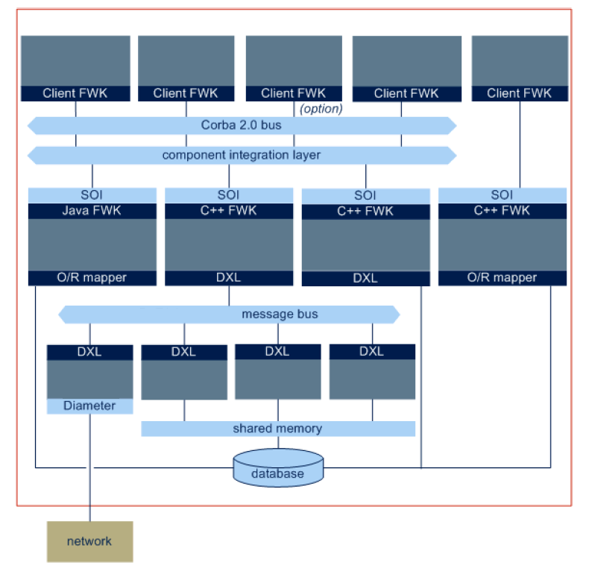
Figure 1: Deployment Components

Server Side Modules

Specify the responsibility and technology of the server side modules….

- SS_Module-1: Purpose of this module is ….. The development technology of this module is based on PLSQL/EJB/Corba/Tomcat-JSP….(state the server side standard used)
- SS_Module-2: Purpose of this module is ….. The development technology of this module is based on PLSQL/EJB/Corba/Tomcat-JSP….(state the server side standard used)
- …

Online / GUI Modules

Specify the technology/approach of the GUI side modules….

- GUI_Module-1: Purpose of this module is ….. The development technology of this module is based on Java-Swing/HTML-JSP/.NET ….
- GUI_Module-2: Purpose of this module is ….. The development technology of this module is based on Java-Swing/HTML-JSP/.NET ….

Database

Specify the technology/approach of the DB side such as Oracle with 10gRAC option etc.
….

Other
Specify the technology of the others if any
….

Software Platform

- Relational database and Persistence environment: [Module Name] persists its application specific data using [Oracle RDBMS/ local files in TEXT format/ local files in binary format etc.]. The RDBMS used is: [Oracle 10g/ MySQL….]. In order to interconnect with the RDBMS, [Oracle thin JDBC client/xxx JDBC/ Oracle Call Interface/ Oracle ProC …] has been used for the development of the module.
- Development Tools: [Module Name] has been developed with these development and automation tools; [PLSQL and TOAD/ Eclipse / Netbeans / GCC and GNU Make / Java and ANT…]
- Development Languages: [Module Name] has been developed with these development languages; [Java/ C /C++ / C# / perl / phyton…]

Hardware Platform

Server Side
The below table represent the hardware requirements for the server side functionality.

System Processor: | Itanium
Required Memory  for Module: | 4GB
Required  Free Disk Space  for Module: | 10GB
Operating System: | HP-UX 11.23
Networking: | Required by module to;  - Access Oracle RDBMS  - …
Dependent Software&  Libraries: | STD Template Library V4.5, Hibernate…, JRE 1.5 , etc.

Online / GUI Side
The below table represent the hardware requirements for the Online / GUI side functionality.

System Processor: | 800MHz, Intel …
Required Memory  for Module: | 512MB
Required  Free Disk Space  for Module: | 50MB
Operating System: | Windows XP / Windows Vista
Networking: | Required by module to;  - Access Oracle RDBMS  - …
Dependent Software&  Libraries: | Outlook installed with all libraries  .Net vX runtime libraries  web browser IE6  JRE 1.4 or higher

Installation

What other software must be installed first?
Before you can install this product, you must install the following packages:
- Java SDK
- Apache Tomcat
- Oracle database
- OTHER PACKAGES…

Installation of ZZZ-SubModule-1

How do I install?
Please follow these steps:
- STEP
- STEP
  - SUB-STEP
- STEP
- STEP

How can I uninstall?
- STEP
- STEP
  - SUB-STEP
- STEP
- STEP

Installation of ZZZ-SubModule-2

How do I install?
Please follow these steps:
- STEP
- STEP
  - SUB-STEP
- STEP
- STEP

How can I uninstall?
- STEP
- STEP
  - SUB-STEP
- STEP
- STEP

Known Problems and Workarounds

- DEFECT 07293 Screen frozen when…
  - WORKAROUND: Set Language to…
- DEFECT 10509 Cannot switch directly from ..
  - WORKAROUND: Switch to local mode.
- DEFECT 10589 crash while booting sub application
- …

Getting Started and First Time Run

How can I quickly get started and test my installation?

- STEP
- STEP
  - SUB-STEP
- STEP
- STEP

Appendix

Document Control

Superseded Documents
- N/A

Change Control & Distribution
Owner | [OWNER NAME]
Reviewer
Approved By
Distribution
File Name | 0000.doc

Version History
Version | Change Descriptions | Author | Date
1.0.0 | Initial Version | [Author Name] | 01/Jan/2014

Approvals
This document requires the following approvals:

Name | Title | Date | Signature | Version

